MACH4METAL

metalworking machinery
Transito 21
6909 DA BABBERICH Netherlands
Tel. +31 (0)316-247123
Fax: +31 (0)316-247956
info@mach4metal.com
www.mach4metal.com

Bank No : 66.52.13.883
IBAN : NL33 INGB 0665 2138 83
BIC : INGBNL2A

LUCAS Trimming & bearding
Semiautomatic hydraulic horizontal
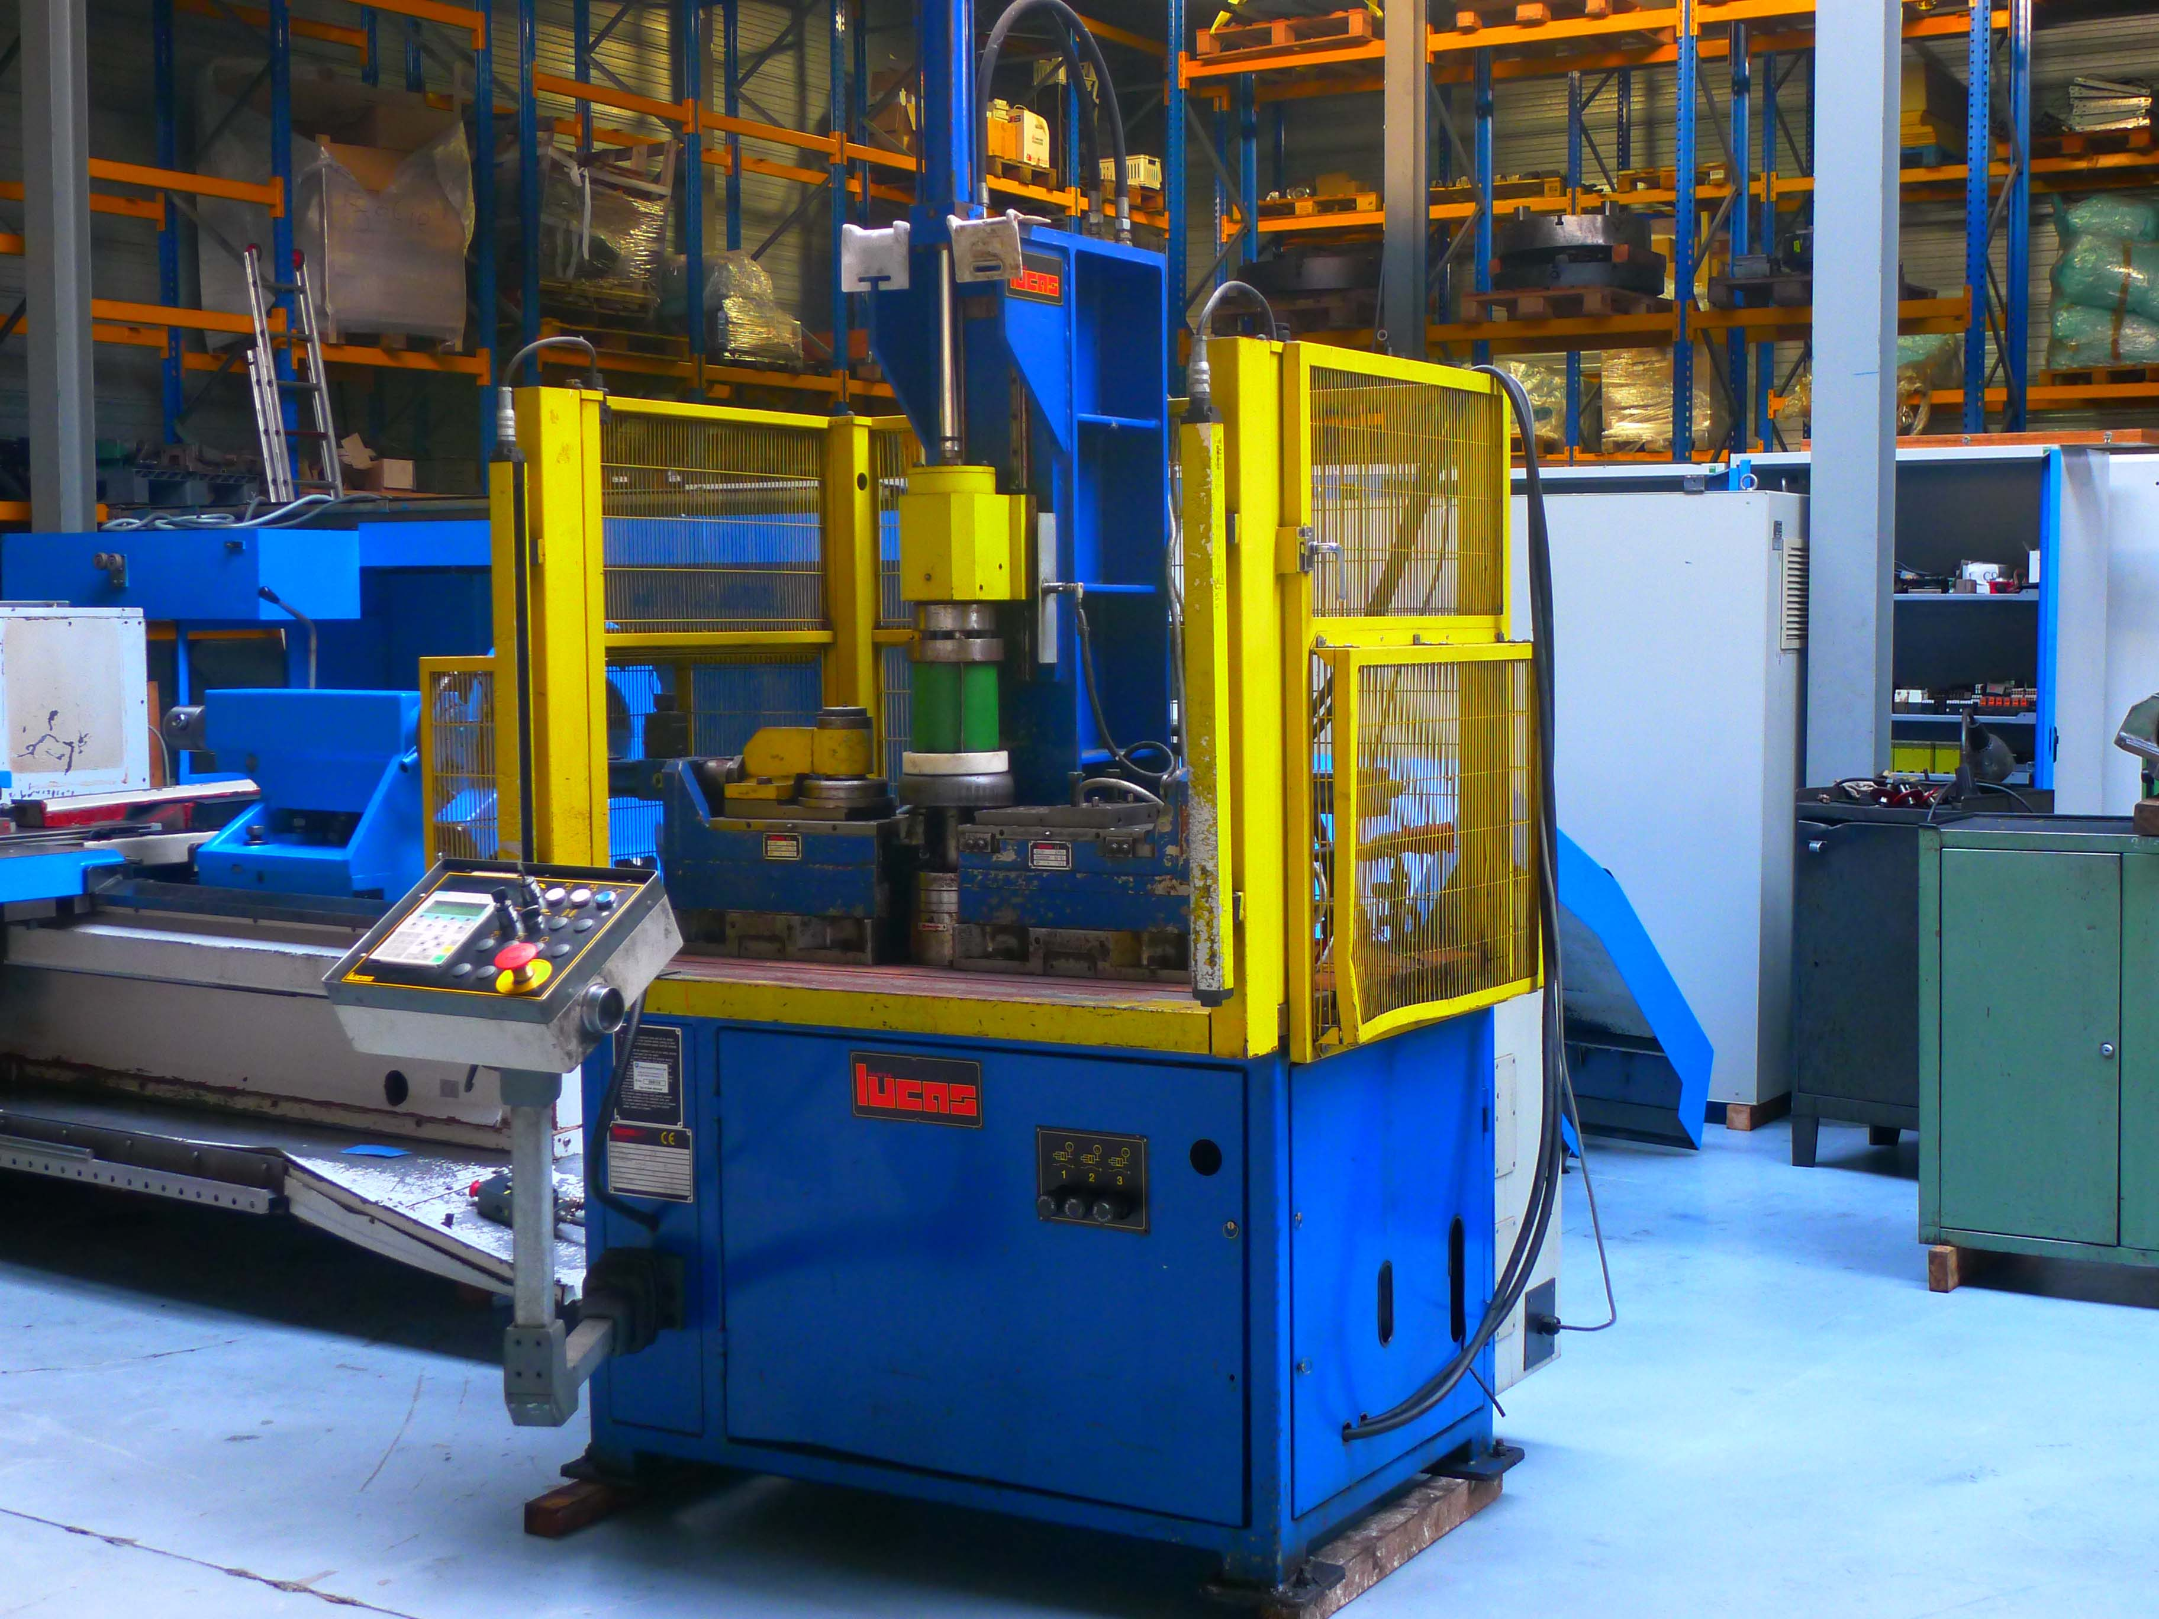
- Make : LUCAS Italia
- Typ : VBU 400
- Age : 12 . 2001
- Serial.No. : 2556

- Max. work pieces Ø : 500
- Max. stroke cylinder : 350
- Speeds : 30 – 300 Rpm
- Semi automatic with programming device

- Capacity round pieces : 5 mm
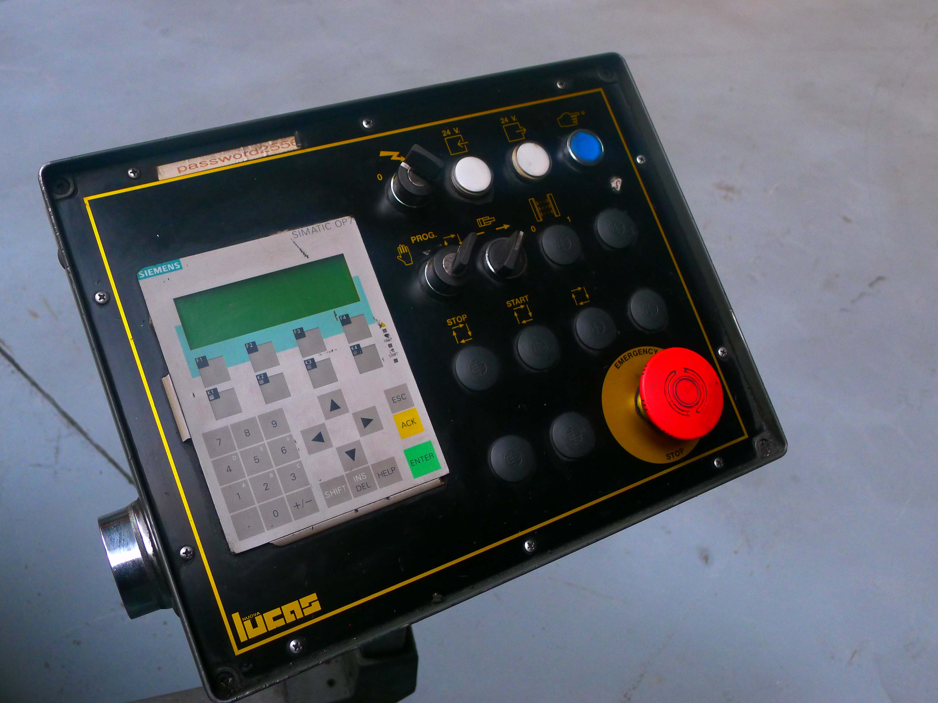
- Capacity polygonal pieces : 2.5 mm

- Table length : 1.350
- Table width : 850
- Troth : 150

- Sick safety guides
- Central lubrication

- Power 400 V / 8 kW
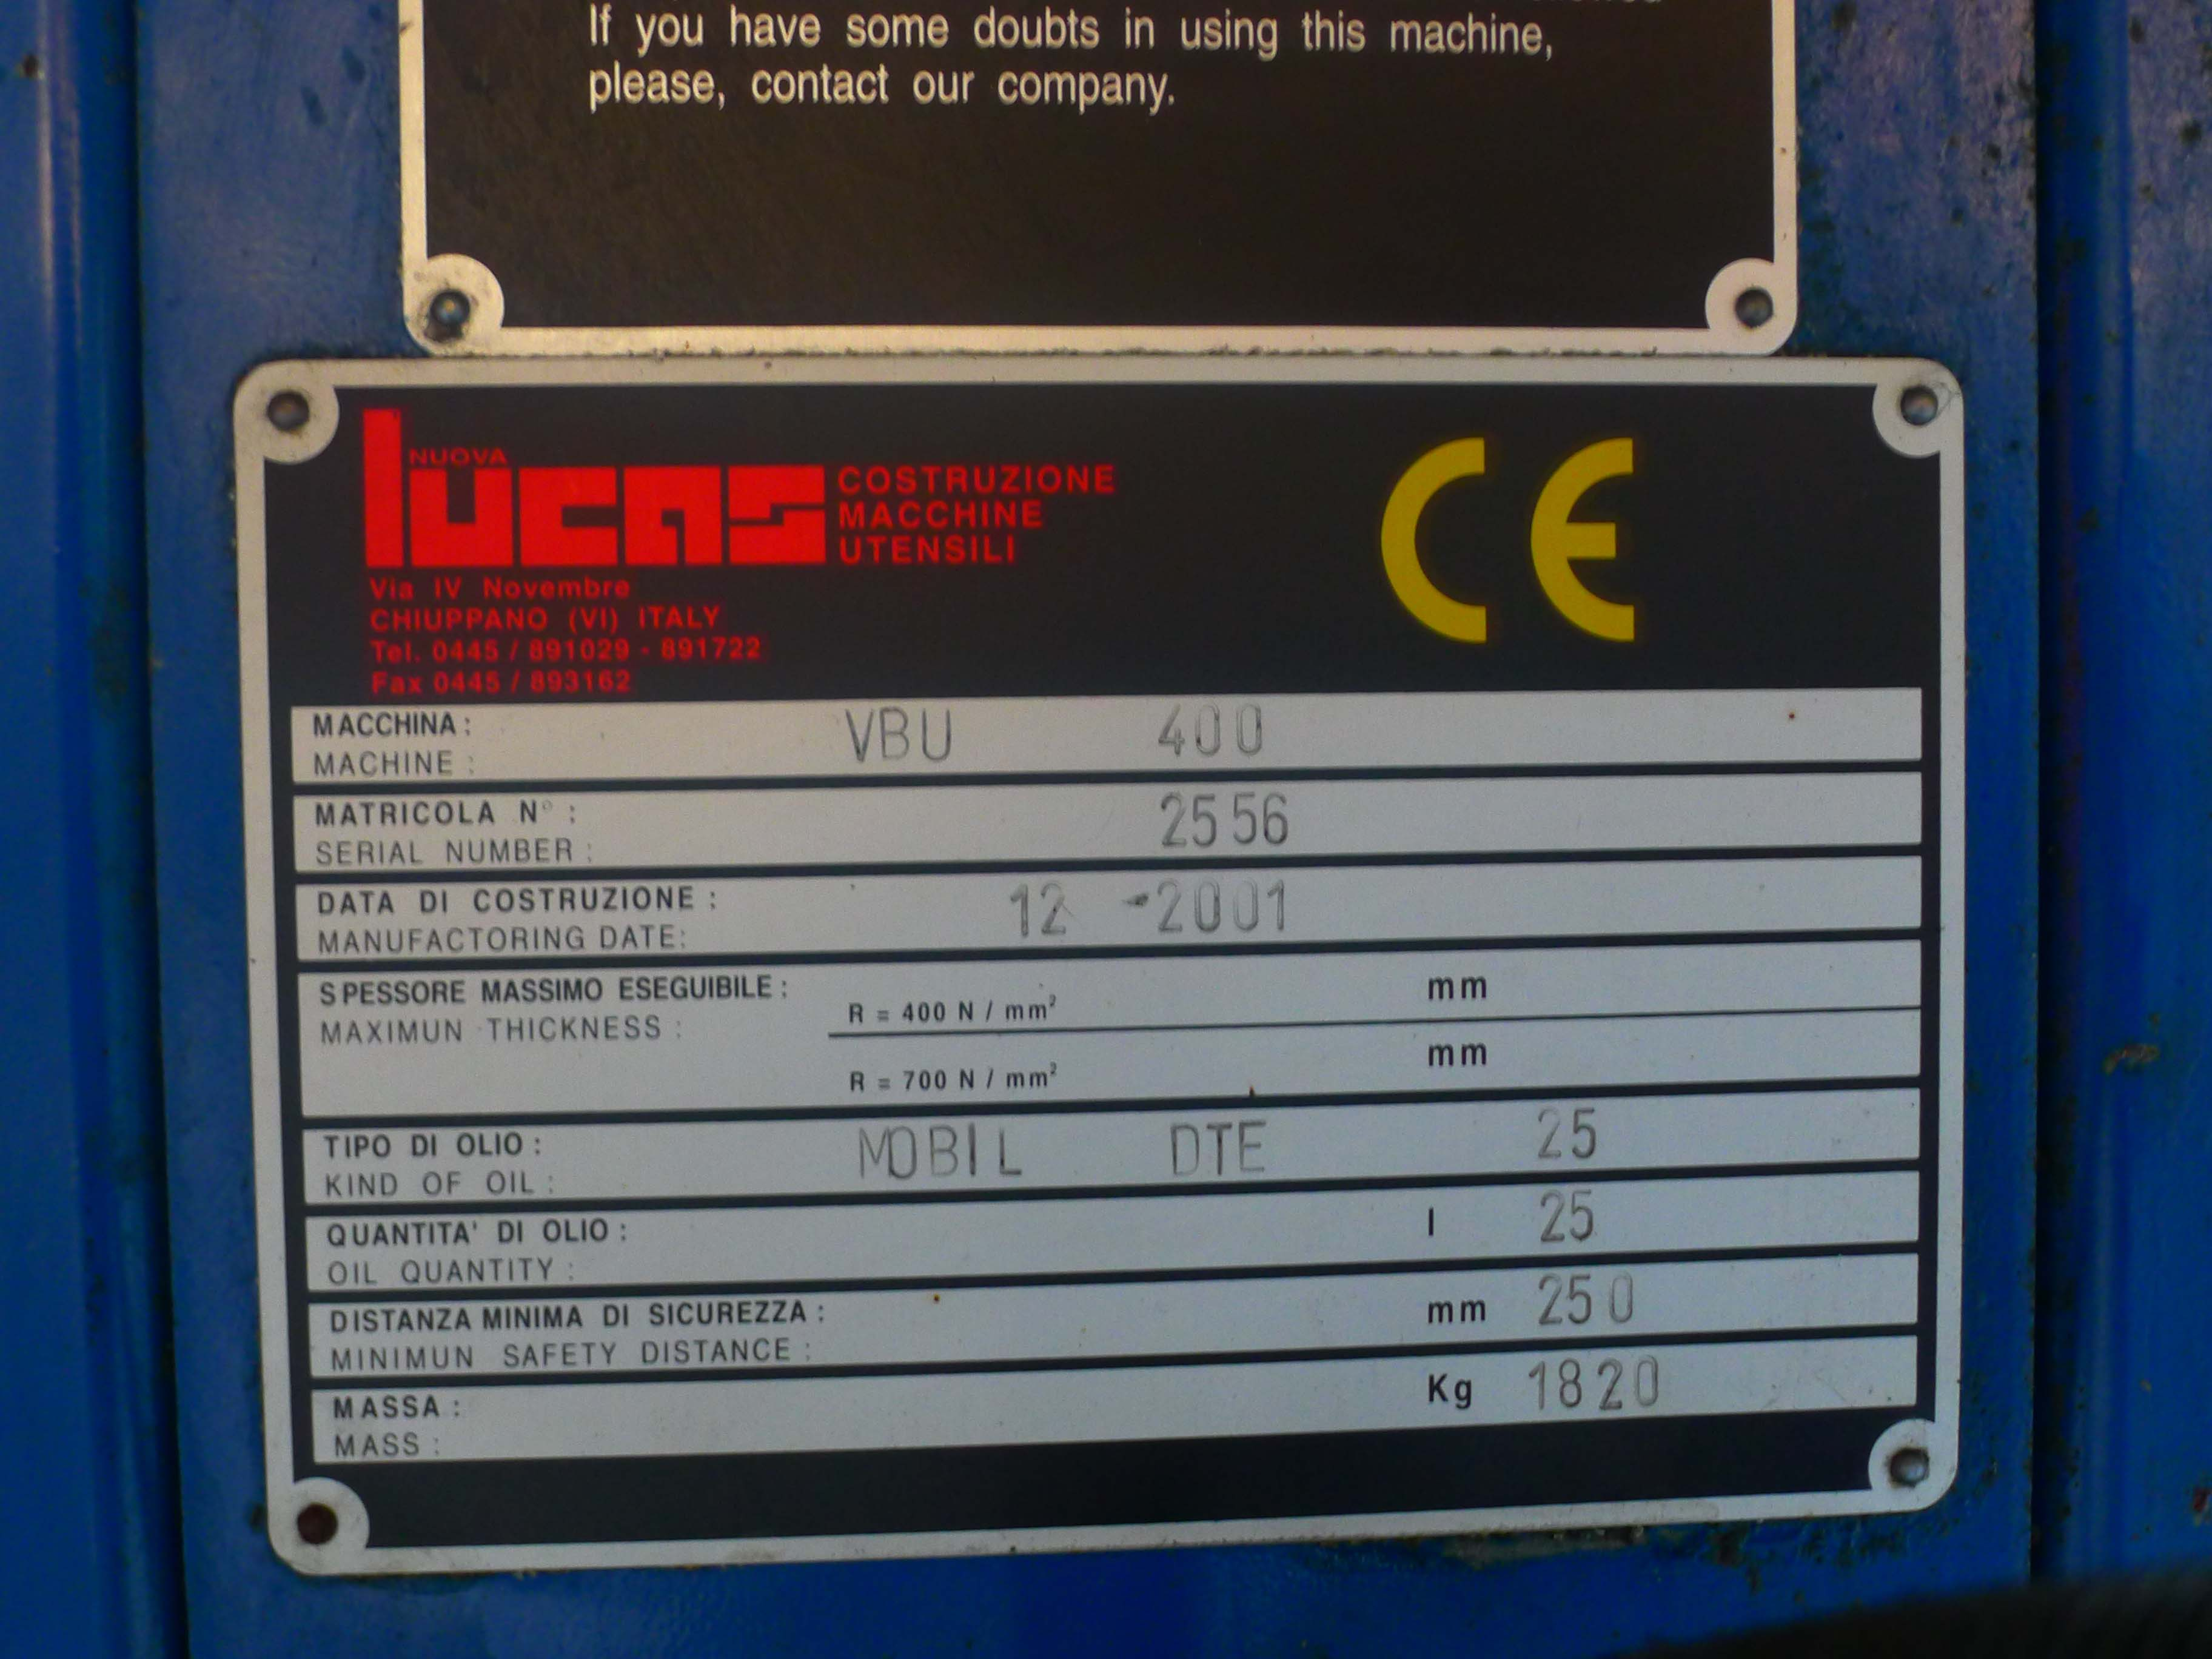
- Length : 1.400
- Width : 1.300
- Height : 2.200
- Weight : 1.500
- Table height : 800

- 2 x Support LUCAS ZHSA
- Incl. some extra tooling

Please Note: The above information has been obtained to the best of our ability and belief from, and from the manufacturers where possible. It is given in good faith, but its accuracy can not be guaranteed. Accordingly, it will not form a representation or constitute contractual terms. We advise you to check any vital details!

